Export RC code files from NCR Debout.ThaiAirportIntercept

Table of Contents

Change Record ii

1. Overview 3

2. Solution Integration 4

2.1. Component installation 4

2.2. Configuration 4

3 Usage 6

4 Troubleshooting 7

# Change Record

|  |  |  |  |
| --- | --- | --- | --- |
| **Date** | **Author** | **Version** | **Change Reference** |
| 25/01/2019 | Akarat Suvitayasiri | 0.1 | Initial document and configuration |

# Overview

This project is for export rc code and creating csv files which contain rc code and check no data by line. Output file will be formatted as RC<YYYYMMDD>.csv following business date of deout.ThaiAirportIntercept log file from NCR developed.

# Solution Integration

This solution requires following software to be installed:

* Nodejs window 32 bit (node-v10.15.3-x86.msi)
* Microsoft .NET Framework 3.5 or higher

## Component installation

To install Nodejs simply start with delivered MSI installer file (node-v10.15.3-x86.msi), this will install all components.

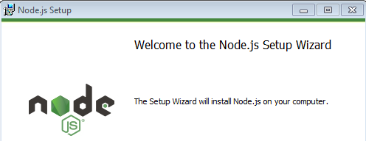

## Configuration

### 2.2.1 Configuration in Minor Program folder

Copy **RCDaily** folder and then put on C:/Minor Program on BOH.

Run setup program by click to run installBatch.bat.



### Configuration each IP Address of POS terminal ID

To configure ip address or share path of hostname for POS terminal ,open or edit ip.json file:

|  |  |
| --- | --- |
| **No.** | **Configuration** |
| POS1 | IP address of termainal no. 1 |
| POS2 | IP address of termainal no. 2 |
| POS3 | IP address of termainal no. 3 |
| POS4 | IP address of termainal no. 4 |
| POS5 | IP address of termainal no. 5 |

On running program the full path each configuration will be assigned to //<ip address>//bootdrv/Aloha/TMP ,please ensure the access of ip address.

# Usage

On starting by run via batch file name as runBatch.bat.

#### Condition:

1) Debout.ThaiAotIntercept files is available on POS terminal <Aloha>/TMP folder

2) Date folder of EOD has been created already on D:/Aloha

3) Output file will export data form Debout log file with EOD Date included on file name and then create output file

#### Outout:

Output csv file for rc code information generating by business end of day :

For example file and location as below

#### 

#### Data:

Data format in csv file contain 4 values each line

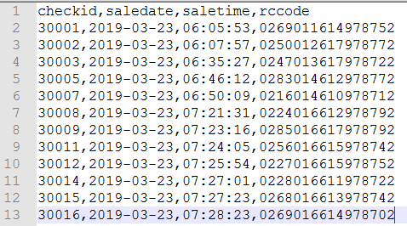

# Troubleshooting

N/A